Jump Start Joey Scouts

HOW TO RECRUIT

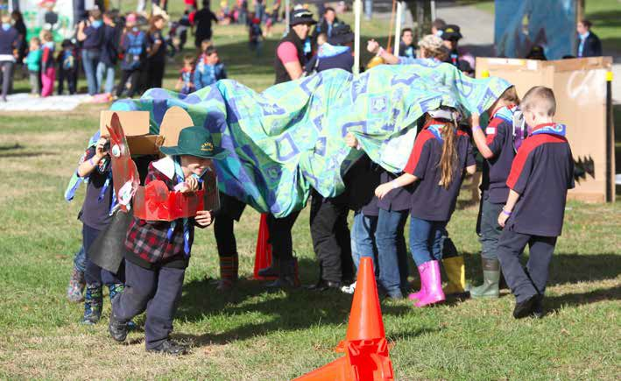

CONTENTS
RECRUITMENT PACK
- Finding Joey Scouts
- Finding New Leaders

ABOUT THIS MANUAL
Jump Start Joey Scouts is aimed at Groups and Joey Units who have are active but are wanting to recruit new Joey Scout youth members.
This Recruitment Pack will provide ideas and resources to effectively target new Joey Scouts and Leaders from within your local community.
Good luck!

Promoting your Unit
A Joey Scout Unit can continually advertise the wonderful opportunities Scouting can provide to youths aged 5 to 7 years. This can be done through promotional activities such as: -

  - Being seen in public! This is the best promotional activity! Be “Out and About” having fun activities in your community.
  - “Bring a Friend” Nights. Your current Joey Scouts are your best advertisements for growing your Unit!
  - “Come and Try” Nights. Schedule a night where any potential Joey Scout and/or parents can come along to participate in a Joey night. Use community posters, letter box flyers and Facebook Community pages to advertise this.
  - Participation in community activities such as parades or festivals where youth members can participate in uniform and promote the Group. Assisting other organisations during community events also provides an avenue for promotion. Anzac Day involvement is a good example.
  - School newsletters and participation in school fetes, request a School visit.
  - Scout Hall Open Days
  - Scout Hall Signage.
  - Involving the Unit in Group fundraising events.
  - Regular newsletters and press releases to promote the Unit

Recruiting tools
Here are some of the recruitment resources to support you: -
  - Factsheets. Are a great tool to use to inform people about what Joeys are, as a tool to have a successful Joey Unit and a guide to discussing this project with your Group.
  - Flyers. Flyers raise public awareness and provide valuable information. Carefully plan your timing and distribution. For example, are we going to mailbox drop, leave flyers at schools or libraries? Think about where you are most likely to reach your target audience.
  - Promotional Posters. Be creative about identifying possible places to display your posters. Approach local shop owners and businesses to see if they will allow you to display in their windows or public areas. Most supermarkets have community noticeboards and your local Library or Council Offices may have places to display community notices.
  - School newsletter artwork. Approach your local school Principals and Committees to discuss the benefits that Scouting brings to their community, how Scouting can complement their curriculum and to request approval for contributions or inclusions in the school newsletters. Whilst you are there, don’t forget to ask how Scouting can be of service to the school.
  - Social media art. For use on your Group website pages and Facebook site.
  - Bring a Friend Night Invitation. Have a chat with your Joey Scouts to find out why they love Joey Scouts, and which of their friends would like the opportunity to have as much fun. Choose some dates and run the Bring a Friend program.
All of these Resources can be found on Q-Store
Here are other valuable ways to spread the word about your Joey Scout Unit: -

Leveraging Current Members
Parents and youth members understand the benefits that Scouting has provided them. Utilise their enthusiasm and support to help spread the word and find new Joey Scouts and Leaders. Ask Group families for their assistance by: -
  - Sharing the flyer and/or come and try invite with family, friends and neighbours with young school-age children
  - Asking their schools to let them distribute materials, put up posters, or get something in the school newsletter. It is difficult for a school to say No to parents who have a strong relationship with the school (eg on School Council, a regular volunteer at working bees). It’s easy for a busy school to ignore the local Group Leader.
  - Allowing the Group to use their front fence for 6-8 weeks (if they live on a busy road) for a poster.

Your Group Webpage
Websites are important. Many potential youth members and their parents use a Google Search as their first way to engage with the Scouting organisation in your community. Website are searchable though Google and other search engines when a parent is looking for ‘suburb + Scouts’.
The first view of your website needs to be both engaging and informative. The content on your website should be: -
  - Informative, up-to-date and compelling
  - Create a positive and lasting image of Scouting
  - Make it easy for them to take their interest to the next level.
An engaging website with a prominent link to a webpage about your Unit will: -
  - Provide information about the Joey Scout Section, its aims and objectives, the program, and the benefits to youth.
  - Provide links to specific pages in the Scouts SA website.
  - Inform interested parents how to contact the Group by email or telephone.
  - Encourage parents to be involved with the Unit.
  - Encourage parents to revisit your site (for example by providing up to date information on programs and events).
  - Keep Group families informed.
  - Display photos of your Joey Scouts involved in a program that is adventurous, fun, challenging and inclusive.
  - Share good news stories such as the level of public interest or any prospective Joey Scout Leaders.

By Answering Enquiries Promptly
When you get interest in joining your Joey Unit, a quick and positive response will encourage referrals to other families. Some ideas for good email practice include: -
  - Answer all emails promptly.
  - Email enquiries should also be shared with two or three members of the Group Council to ensure at least one Council member is available to respond.
  - Have a list of the types of questions typically asked and the responses, for future reference.
  - Keep statistics on the number of email enquiries or questions received including the type. Understanding the types of enquiry may identify areas where the Group needs to provide further information, clarify the information provided or include information that has been overlooked.

CHECKLIST 1

The Unit meeting times and contact details on the Group hall sign is up-to-date.
Procedures have been established to respond to public enquiries.
A Unit promotional and recruitment program is a regular part of the Group’s calendar.
Procedures have been established to review the type of questions/enquires received and to update the Group website.
The Group website is up-to-date and adheres to Scouts SA guidelines.
Ensuring that all the important administrative tasks associated with registering a new youth member are up to date.
The Group has a sufficient supply of Group scarves, membership badges, and District badges for all your enthusiastic new Joey Scouts!
Does your Group include ongoing recruitment targets as part of your strategic planning?

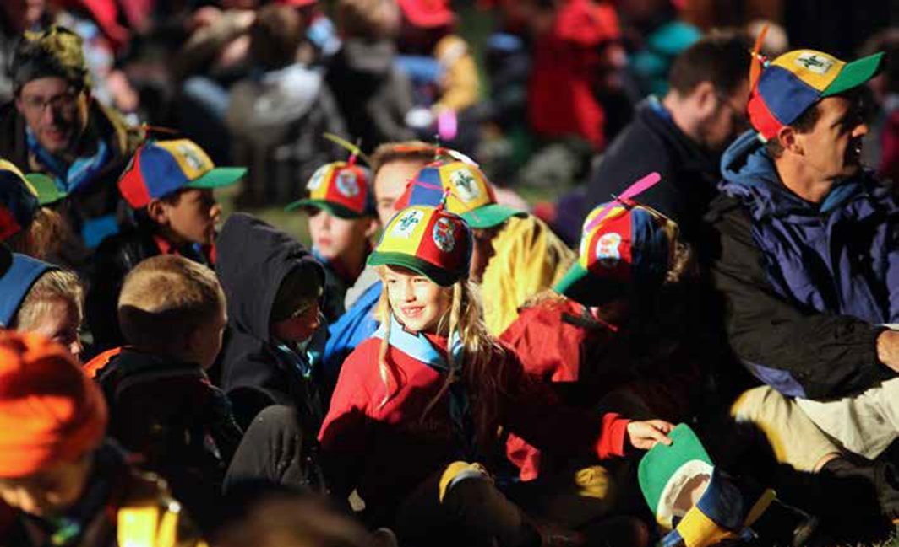
Finding New Leaders
How Can We Recruit New Leaders?

Create a friendly, welcoming family type environment where parents what to join and be a part of an amazing Group. Some of the most successful Groups in the state also have social activities for their leaders and Group Support Committee, why should the youth have all the fun! Supporting each other and sharing the good times as well as the hard times is very important in a strong group which will continue to grow organically.

LeaderBuild
LeaderBuild is a proven process to recruit new Leaders and the Group should invite all Group families to a Leaderbuild session with the focus of securing additional Joey Scout Leaders.

Current Venturer Scouts and Rovers
Current youth and adult members may respond favorably to an invitation to become a Joey Scout Leader as part of their award scheme. Review the Group’s records to identify current Venturer Scouts and Rovers who may be interested in taking on a Leadership role.

Past members
Review the Group’s records to identify past members who are of leadership age and send them a letter highlighting the Group’s achievements and openly enquire whether they would consider becoming a Leader. Don’t forget invite them to your LeaderBuild session.

Past youth members may respond favorably to an invitation to become a Joey Scout Leader because: -
- They have an affinity with your Group having been a youth member.
- Being youthful they have a sense of adventure, fun and involvement; great attributes for a Joey Scout Leader.
- They will recall their own Scouting memories, achievements and activities as a youth member.
- They may have an interest in “giving back” to the Movement and your Group.
- They have skills which can be passed on to youth.
- They may have a child that is eligible to join the Unit.

You may have a qualified Leader in another section who wishes to transfer to the Joey Scout Section. This is great, but make sure that adequate support is provided. This might be by some mentoring from another Joey Scout Leader in another Group.
Who else can you use as Interim Joey Leaders?

Roster of Leaders within your Group
As a Group Leader, your primary focus is to ensure that the Joey Scouts continue their Scouting experience and this can be achieved by utilizing other Section Leaders who have completed their training, as an interim measure whilst the Group recruits sufficient Joey Scout Leaders. With a roster of the Group’s Leaders in place, the Unit can continue to operate until your new Joey Scout Leaders have completed their required training.
In need, call upon experienced Joey Scout Leaders from your District and Program Mentors from the Program Support Team.

CHECKLIST 2

Set future dates to run a Leaderbuild sessions, to assist with recruiting new Leaders.
Current Venturer Scouts and Rovers, as well as past youth members have been invited to become Joey Scout Leaders and have been invited to the Group’s LeaderBuild session.
All Group families have been invited to the Leaderbuild session.
A Group roster of Adult Helpers and Parent Helpers is in place to assist the Leader-in-Charge.

