 | Scouts SA  Paddling Team Activity  Booking Application  - Patawalonga - | 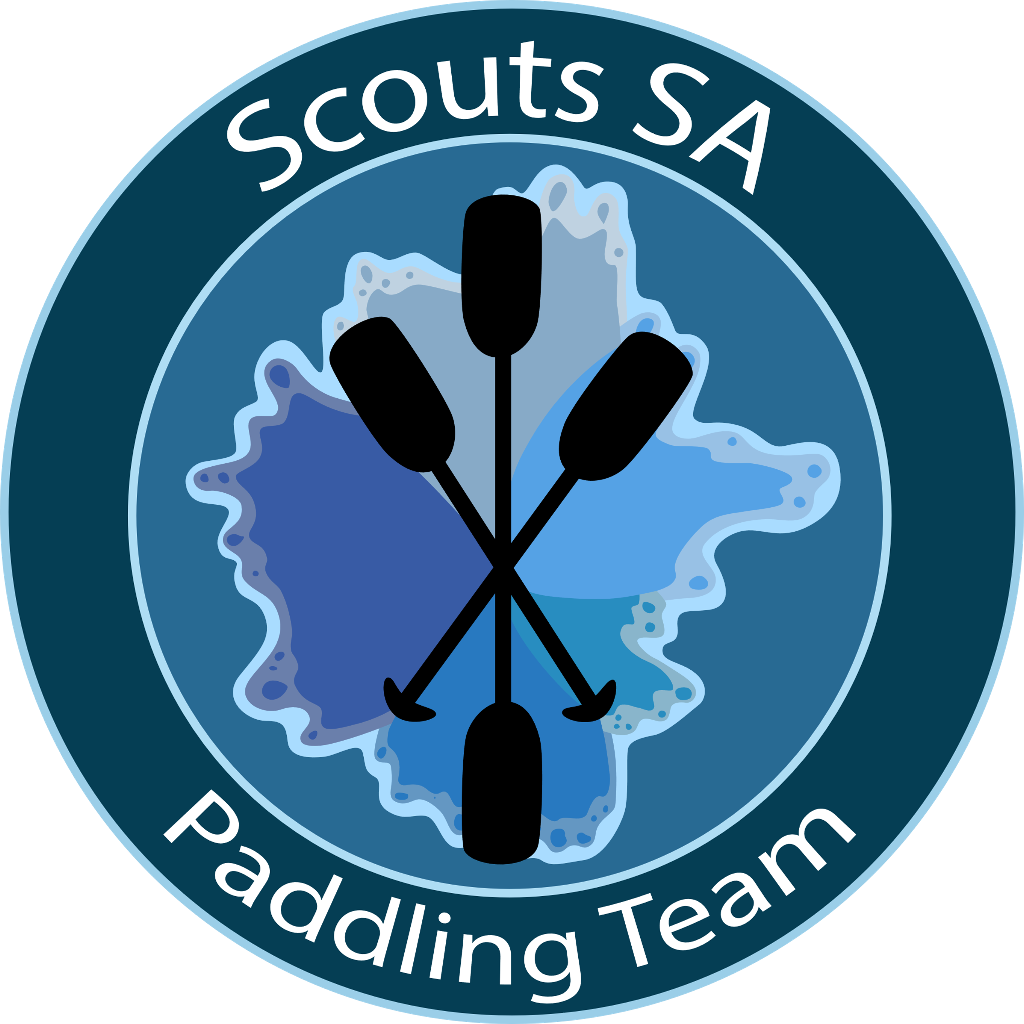  Contact –  bc.paddling@sa.scouts.com.au

This form is used to book a Paddling Activity with the Paddling Team at the Adventurous Activities Centre at Glenelg on the Patawalonga.
A minimum fee of $50 per session is required – no matter how many participants. Groups may combine if necessary.
A standard fee of $8 per person / session applies. This covers hire of canoes/kayaks/paddles and PFD’s. This includes all leaders and parents that participate in the on-water activities.
CANCELLATION POLICY:
The activity may be cancelled due to weather (see note 1 on page 3). It is the Groups responsibility to have an alternative activity and site in place (Obviously no fee will apply). The Group is to notify the BC Paddling at least 14 days before the event of a cancellation (else the minimum fee will apply) or major change of numbers.
A standard weeknight program starts at 6 PM and finishes at the discretion of the Paddling Section Leader in charge. The main contributing factor is night fall and varies considerably through the season. Other programs start at the agreed time.
Group Details
Note: Due to COVID-19 during Term 4, 2020 no more than 15 Youth will be able to be catered for.
Name of Group/s
Section – Joeys/Cubs/Scouts/Vent/Rovers
Number of participants
Preferred Activity (Kayak / Canoe)
Please note that depending on the weather conditions and in line with SS&P’s the Paddling Team in consultation with the Group may choose to alter the activity.
Contacts
 | Name | Phone | email
Primary Contact
Alt Contact

Dates

During Term 4, 2020 Come and Try Activities are being offered on the following dates:

November 2020  Monday 2nd  Thursday 12th  Wednesday 18th | December 2020  Sunday 6th (10am or 1:30pm)  This date has been booked out. | Preferred Dates in Order of Preference
Please check availability of dates with the BC Paddling
To ensure a Safe & Fun Paddling Experience for all please ensure the following are actioned
At least 14 days prior:
□ Submit this application to BC Paddling. Check with BC Paddling on availability of above dates.
□ A4 / Y4’s completed
□ Ensure there is only a maximum of 1 Adult per Youth member attending
□ Inform all who will be attending that they must not attend if they are unwell. This includes those who are not participating in the activity
□ Advise families that those not participating will be required to stay either in the car park or the lawn area adjacent to the car park. They will be required to stay away from where the activity is being run unless requested by a member of the paddling team to assist with the moving of boats

On the Day prior to the activity commencing:
□ Check with all who are attending that they are well
□ Ensure there is only a maximum of 1 Adult per Youth member attending
□ Ensure all who are in attendance, including those not participating complete the sign in process after sanitising the hands of everyone they have brought with them. Note: The sign in sheet will be kept with the Paddling Team. It is recommended that the leader in charge of the group takes a photo of this sheet before leaving the activity. A copy can be emailed out on request.
□ Advise the leader in charge of any medical conditions, etc that need to be taken into consideration

After the Activity:
□ Confirm with the leader in charge the number of participants
□ An invoice will be emailed to the contact on the application form within 24 hours of the activity
□ Payment within 7 days would be appreciated

Notes
- Weather
If the weather conditions are outside the limits set by SS&P’s the activity may be cancelled, this is at the discretion of the BC Paddling. Unfortunately, the Patawalonga suffers from storm water pollution after local rain and SA EPA regulations limit its use 4 days after such events, please check with the Paddling Team if rain occurs just before the event.

- Clothing
As this is a water activity it is to be expected that all participants will get wet, hence a FULL change of clothing is mandatory. Change facilities may be available depending on State Government regulations at the time.
Mandatory boating clothing includes,
- Top with sleeves – no singlets exposing top portion of the arms are to be worn.
- Shorts / bathers / Hat – sun smart compliant - remember hats generally don’t float
- Boating shoes - old sneakers or water shoes NOT boots/waders/thongs
Other items may include
- Sunscreen / Repellent
- Sunglasses / Glasses retaining strap
- Bag for wet clothing / Towel

- Entrance into the Activity Centre
Access to the activity centre is restricted during Water Activity events. No wet gear is to be worn inside the hall area – Access is restricted to the toilets and shower area only.

- Assistance at the beginning and end of the activity
At the beginning and end of the activities it would be appreciated if all Leaders and Parents could assist in moving the boats to and from the boat shed especially with the Joey and Cub sections. Please ensure all helpers practice social distancing when helping. It is the Groups responsibility to mop the showers at the end of the activity.

Booking Officer Use Only
Date Received |  | Date Selected |  | Date Confirmed

